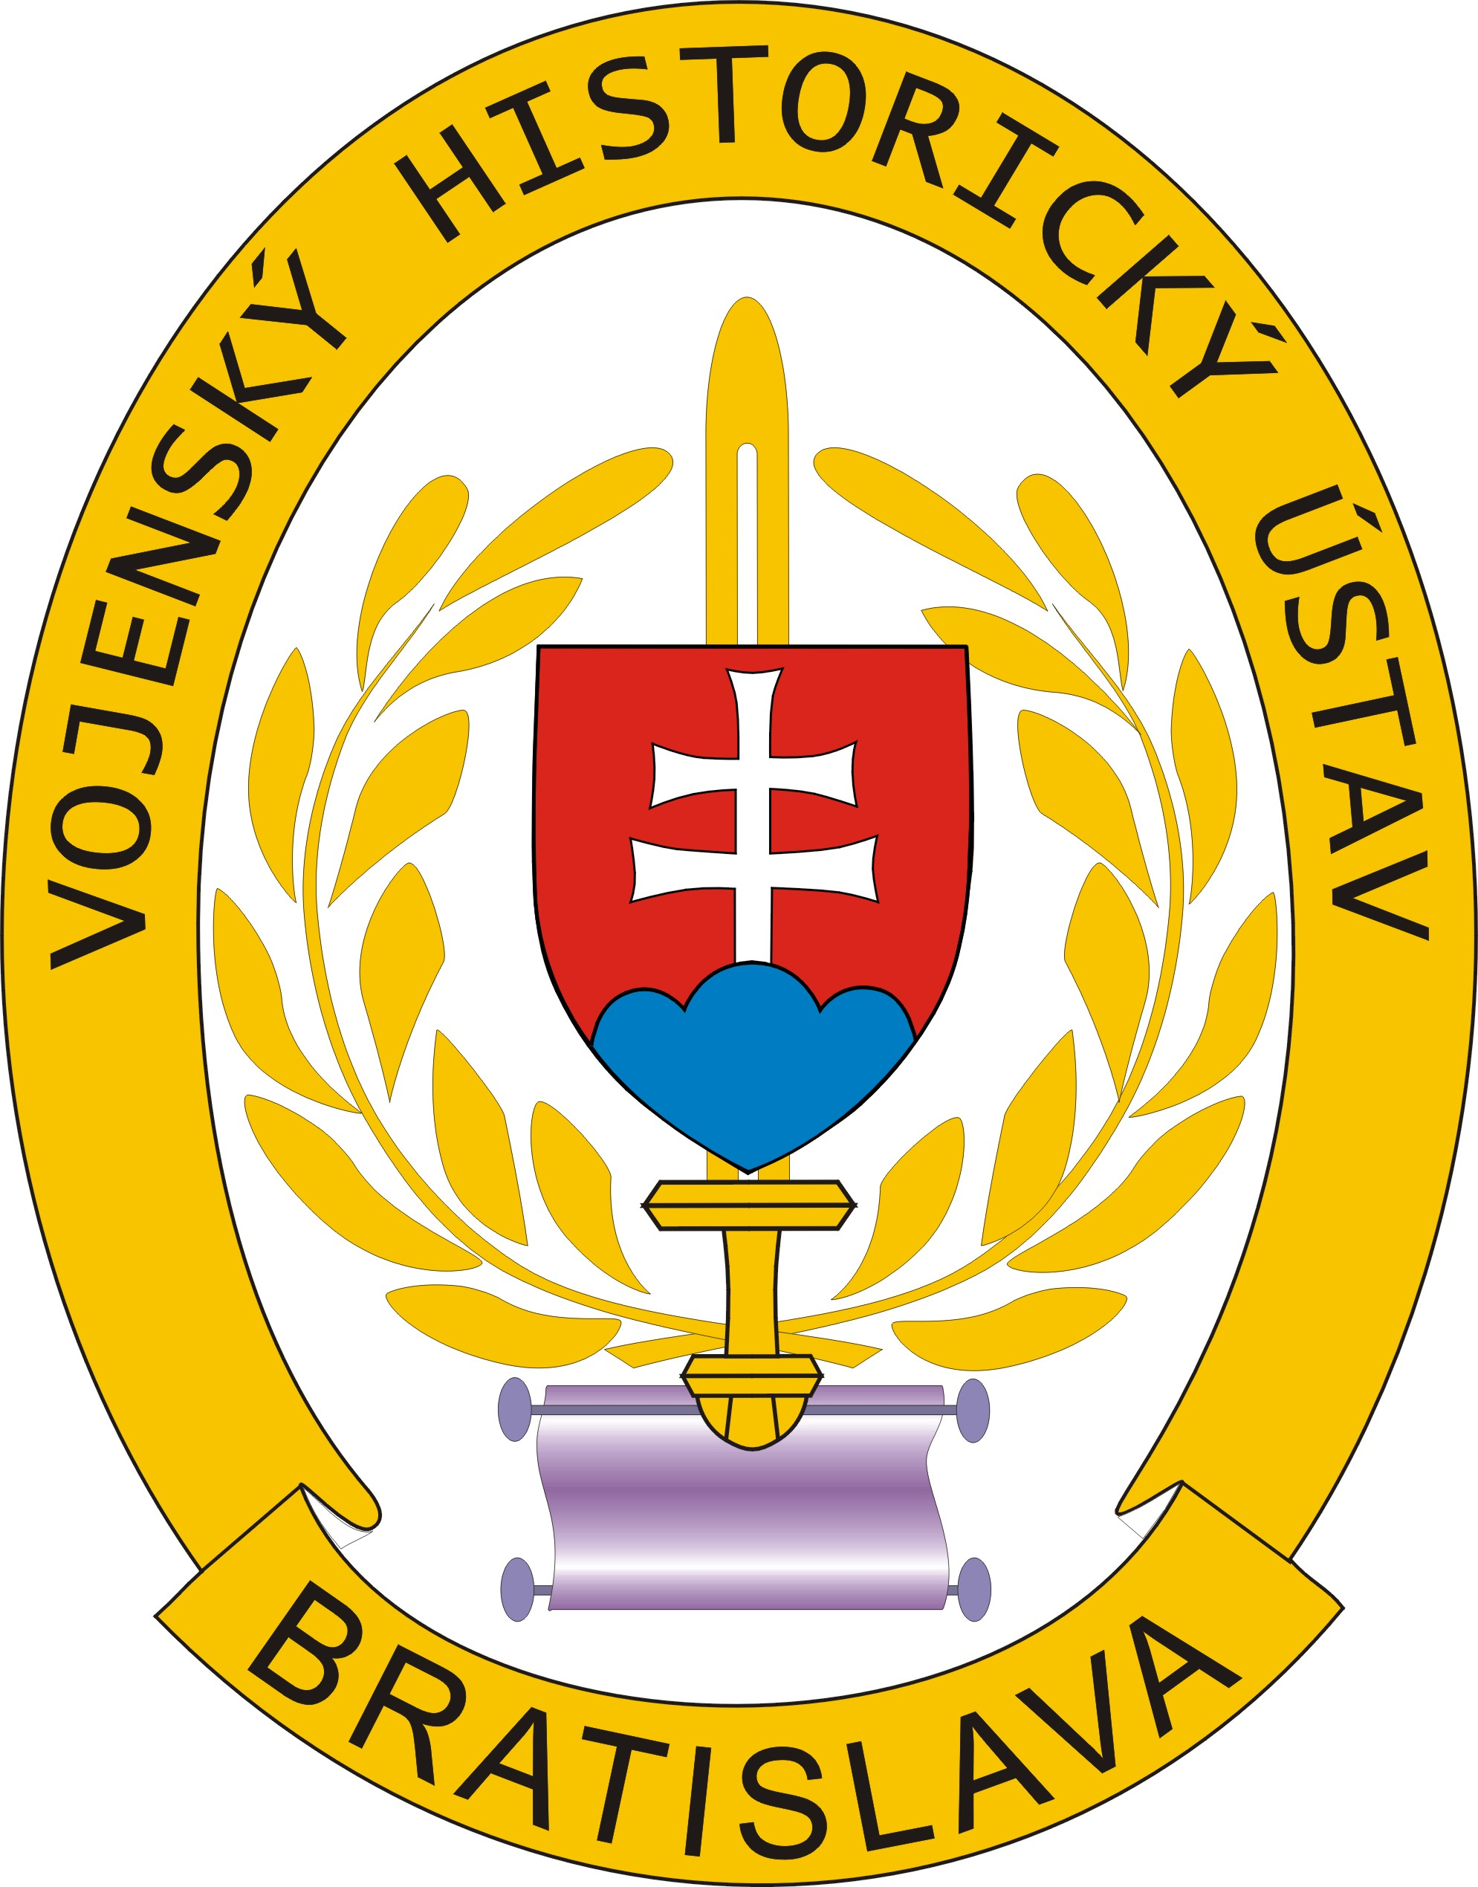 | VOJENSKÝ HISTORICKÝ ÚSTAV  Vojenský historický archív  B r a t i s l a v a  ––––––––––––––––––––––––––––––-

Bratislava 22. apríla 2009

John M. Chmiko Jr.
307 S. Clinton Ave.
St. Johns, MI 48879-1865
USA

Váš list/zo dňa Naše číslo Vybavuje/tel. číslo
- /15. 4. 2009 VHÚ – 5-26/2009 -VHA Andrea Gajdáčová
+421 -2-48 20 77 20

Matter: Response for the application

I announce you to your letter, that in our archive are no primary documents for the person Josef Cmiko, born on 3. 4. 1886 and Valentin Cmiko, born on 13. 2. 1875 where as there are saved primary documents of soldiers and muster gunners of birth years 1911 – 1920.
From this reason I recommend you to contact Central Army archive, Sokolovska street nu. 136, 186 000 Praha 8, Czech republik, where your requested documents should be saved (podatelna@vuapraha.cz).

Best greetings

director
Mgr. Peter KRALČÁK

